1. **Install Power BI Desktop and share the final screenshot of the report view page which appears when power desktop starts.**

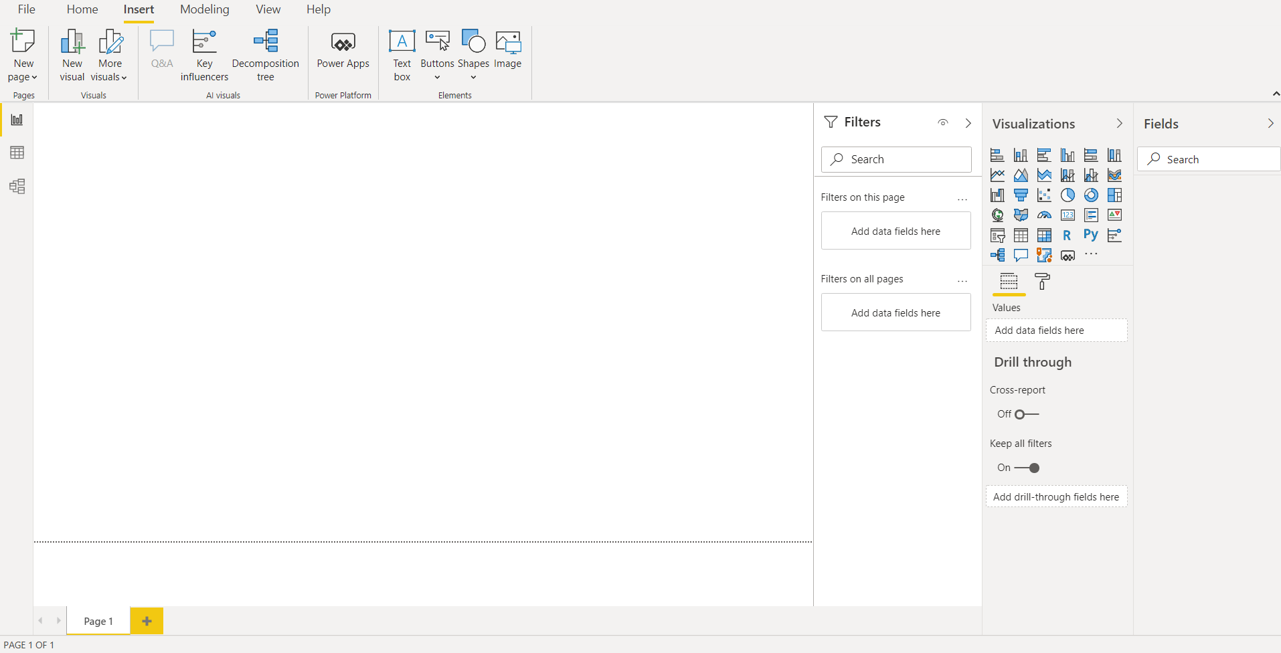

1. **Prepare a document and with the following screenshot −**

* **Report View:**

Power BI Desktop includes a Report view, where we can create any number of report pages with visualizations.

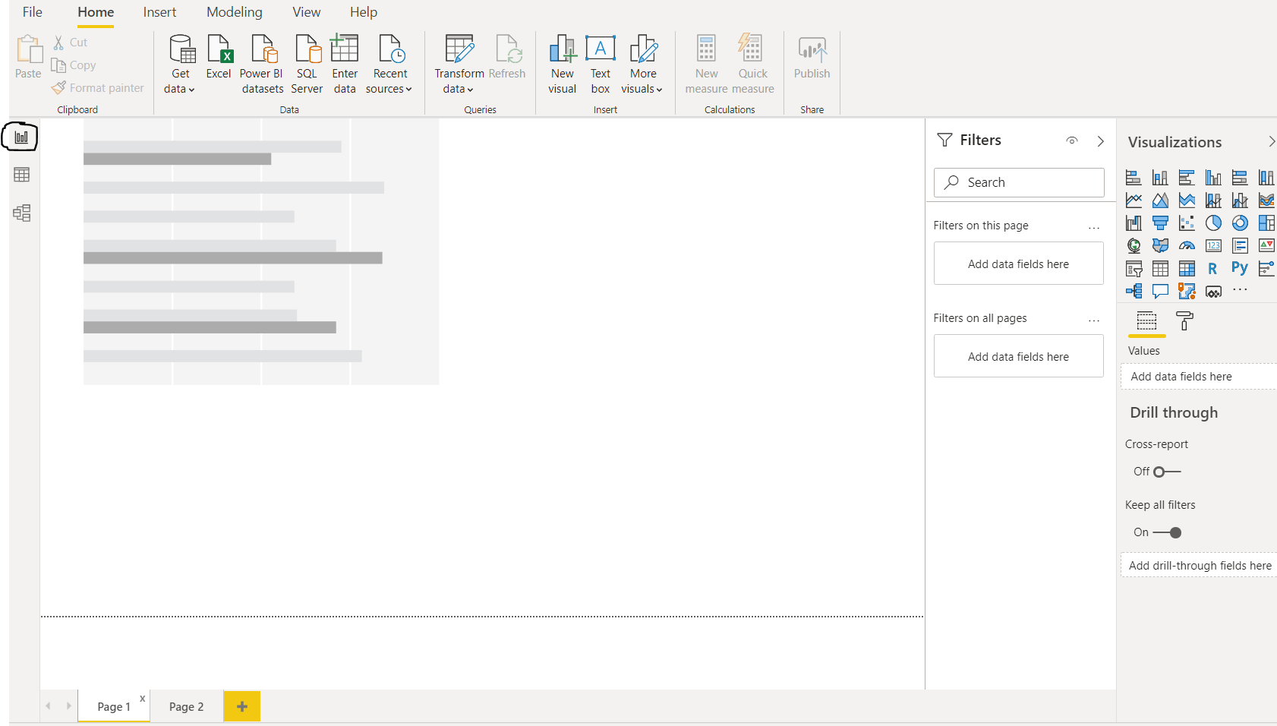

* **Data View:**

Data view helps us to inspect, explore, and understand data in Power BI Desktop model. It's different from how we view tables, columns, and data in Power Query Editor. With Data view, we are looking at the data after it has been loaded into the model.

Below screen shot gives the detailed usage of each field.

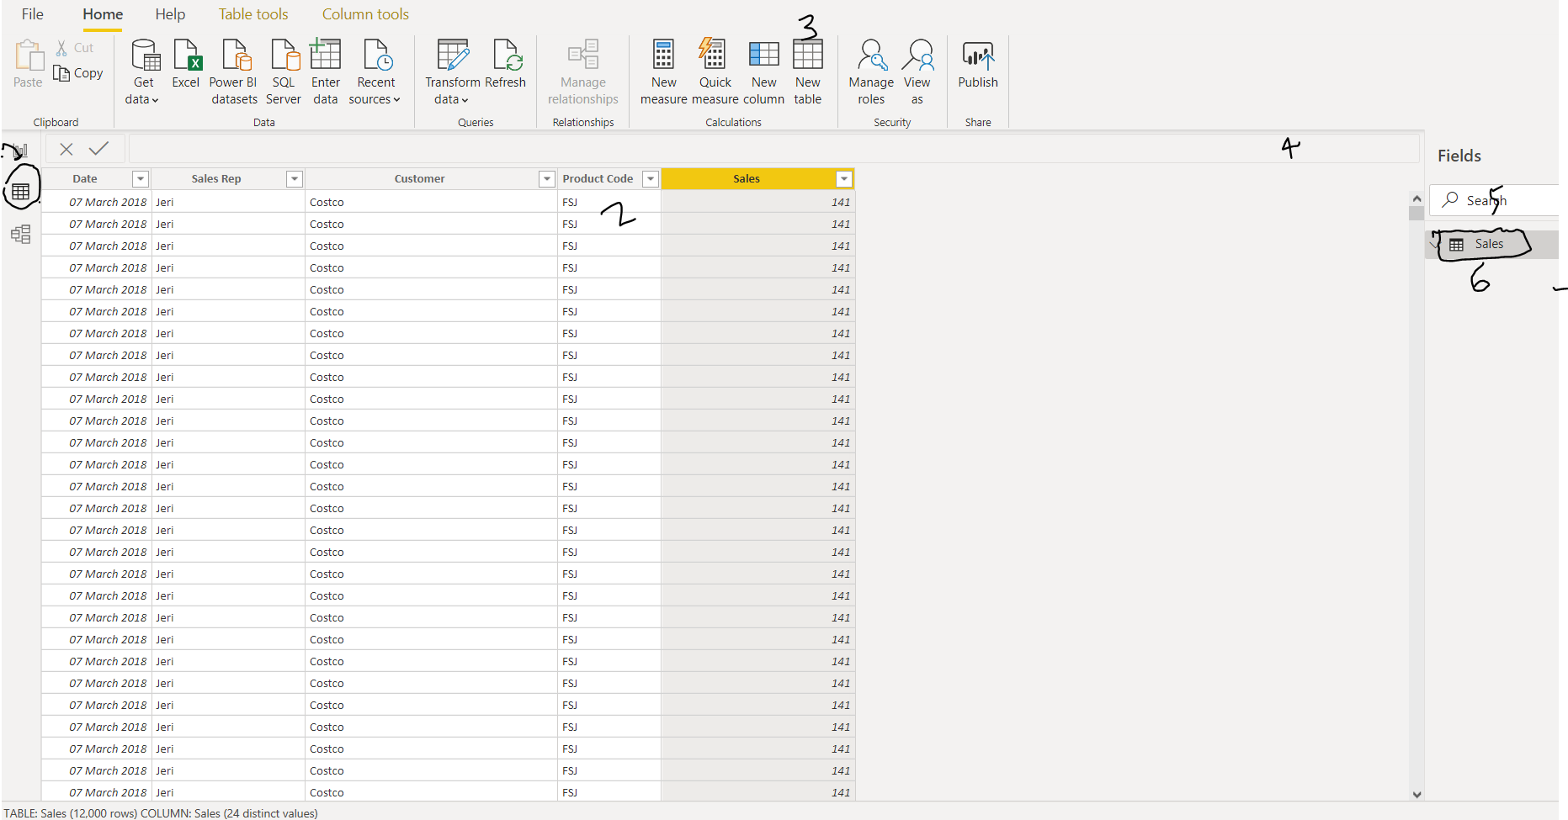

Above number and their usage:

1. **Data view icon** – It selects icon to enter Data view.
2. **Data Grid** - This area shows the selected table and all columns and rows in it. Columns hidden from Report view are greyed out. Also, right-click on a column for options.
3. **Modelling Ribbon** - Here we can manage relationships, create calculations, change data type, format, data category for a column.
4. **Formula Bar** – It enters Data Analysis Expression (DAX) formulas for Measures and Calculated columns.
5. **Search** – it searches for a table or column in the model.
6. **Fields List** – it selects a table or column to view in the data grid.

* **Model View:**

**Model view** shows all of the tables, columns, and relationships in our model. This view can also be especially helpful when our model has complex relationships between many tables.

We can select **Model** icon near the side of the window to see a view of the existing model. However, we can hover the cursor over a relationship line to show the columns that are used.

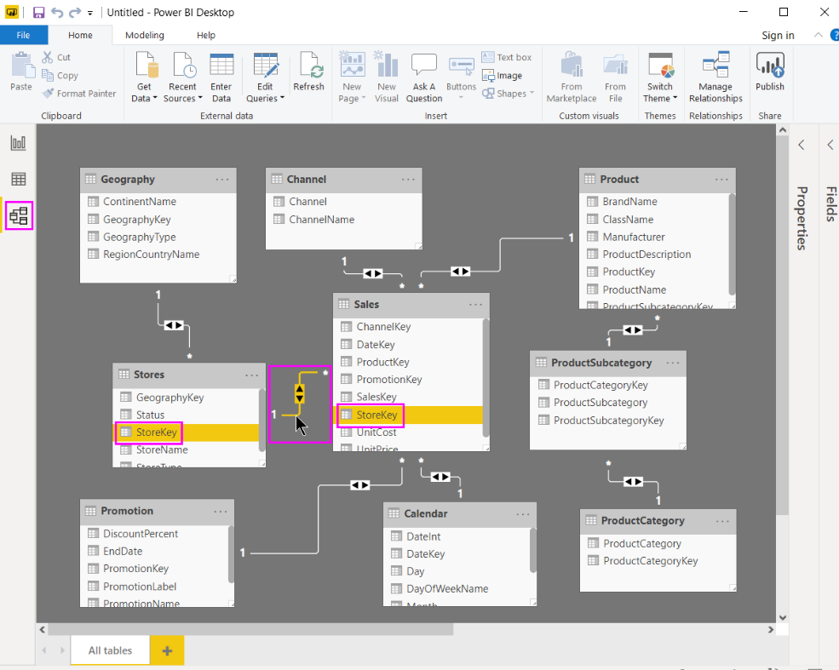

From the above figure we could see, the Stores table has a StoreKey column that’s related to the Sales table, which also has a StoreKey column. The two tables have a Many to One (*:1) relationship.

An arrow in the middle of the line shows the direction of the filter context flow. The double arrows mean the cross-filter direction is set to both. We can double click a relationship to open it in the Edit Relationship dialog box.

* **Power Query Editor:**

It is a component of the power BI desktop which helps us to connect to many different data sources, transform the data into the shape we want, and quickly be ready to create reports and insights. We can also get **Power Query** functionality in the **Power Query Editor**.

**Power Query** is available in **Power BI Desktop** through **Power Query Editor.**

To launch Power Query Editor, we have to right click on the data and select **Edit Query**.

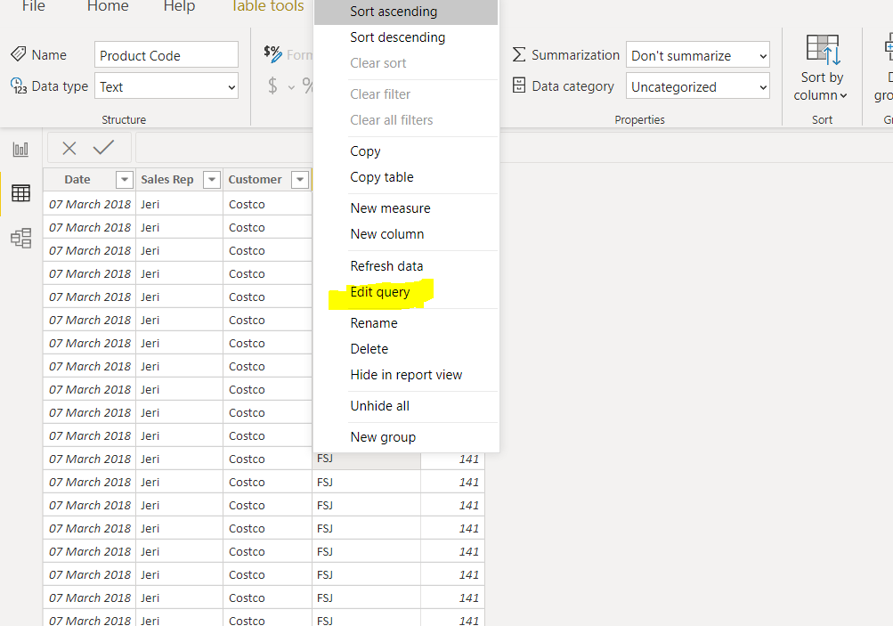

Below image gives the overall view of the power query editor once the data connection is established.

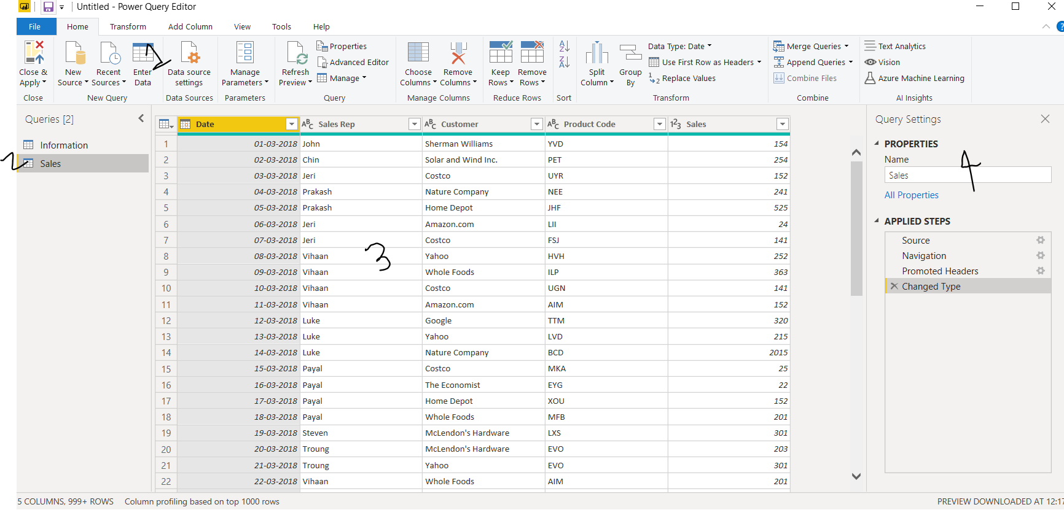

Options we can see:

1. **Ribbon** - In the ribbon, many buttons are active to interact with the data in the query.

2. In the left pane, queries are listed and available for selection, viewing, and shaping.

3.In the center pane, data from the selected query is displayed and available for shaping.

4. **Query Settings** - listing the query’s properties and applied steps.

For more details of each field:

1. **Query Ribbon:**



The ribbon in **Power Query Editor** consists of six tabs—**Home**, **Transform**, **Add Column**, **View**, **Tools** and **Help**.

* **Home –** It contains the common query tasks, including the first step in any query, which is **Get Data.** The following image shows the **Home** ribbon.

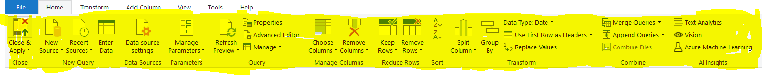

To connect to data and begin the query building process, we have to select the Get Data button. A menu appears, providing the most common data sources.

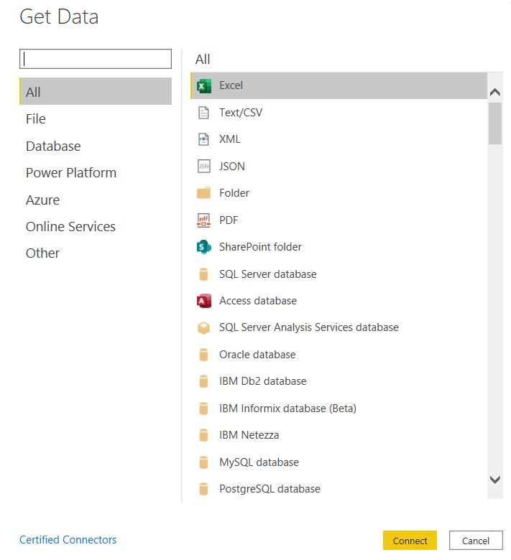

* **Transform tab** - It provides access to common data transformation tasks, such as adding or removing columns, changing data types, splitting columns, and other data-driven tasks.

The following image shows the Transform tab.



* **Add Column tab** – It provides additional tasks associated with adding a column, formatting column data, and adding custom columns.

The following image shows the Add Column tab.

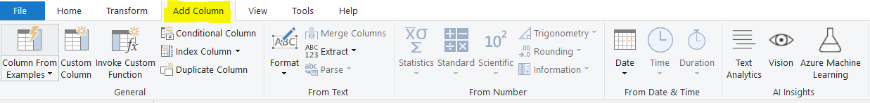

* **View tab** - It’s on the ribbon is used to toggle whether certain panes or windows are displayed. It is also used to display the Advanced Editor.

The following image shows the View tab.

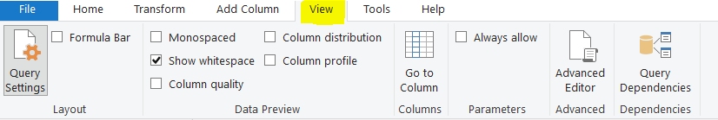

1. **Left Pane:**

The left pane displays the number of active queries, as well as the name of the query. When we select a query from the left pane, its data is displayed in the center pane, where we can shape and transform the data to meet as per our needs.

The following image shows the left pane with multiple queries.

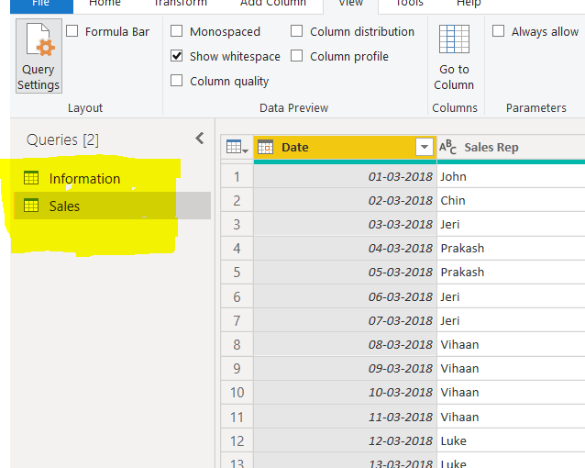

1. **Center Data Pane:**

In the center pane, or Data pane, data from the selected query is displayed. This is where much of the work of the Query view is accomplished.

If we can select any one of the columns and right click on the header section, we can lots of option and we can play it accordingly.

1. **Query Setting Pane:**

**Query Settings** pane is where all steps associated with a query are displayed.

Whatever the changes we have done in the data in the center data pane all steps we can see all the steps under **Applied Steps** field in the sequential manner.

Please see the below screenshot:

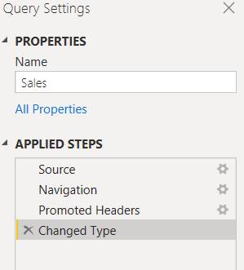

It is important to know that the underlying data is *not* changed; rather, Power Query Editor adjusts and shapes its view of the data, and any interaction with the underlying data occurs based on Power Query Editor’s shaped and modified view of that data.

In the **Query Settings** pane, you can rename steps, delete steps, or reorder the steps as you see fit. To do so, right-click the step in the **Applied Steps** section, and choose from the menu that appears. All query steps are carried out in the order they appear in the **Applied Steps** pane.

* **Advance Editor:**

If you want to see the code that **Power Query Editor** is creating with each step, or want to create your own shaping code, you can use the **Advanced Editor**. To launch the advanced editor, select **View** from the ribbon, then select **Advanced Editor**. A window appears, showing the existing query code.

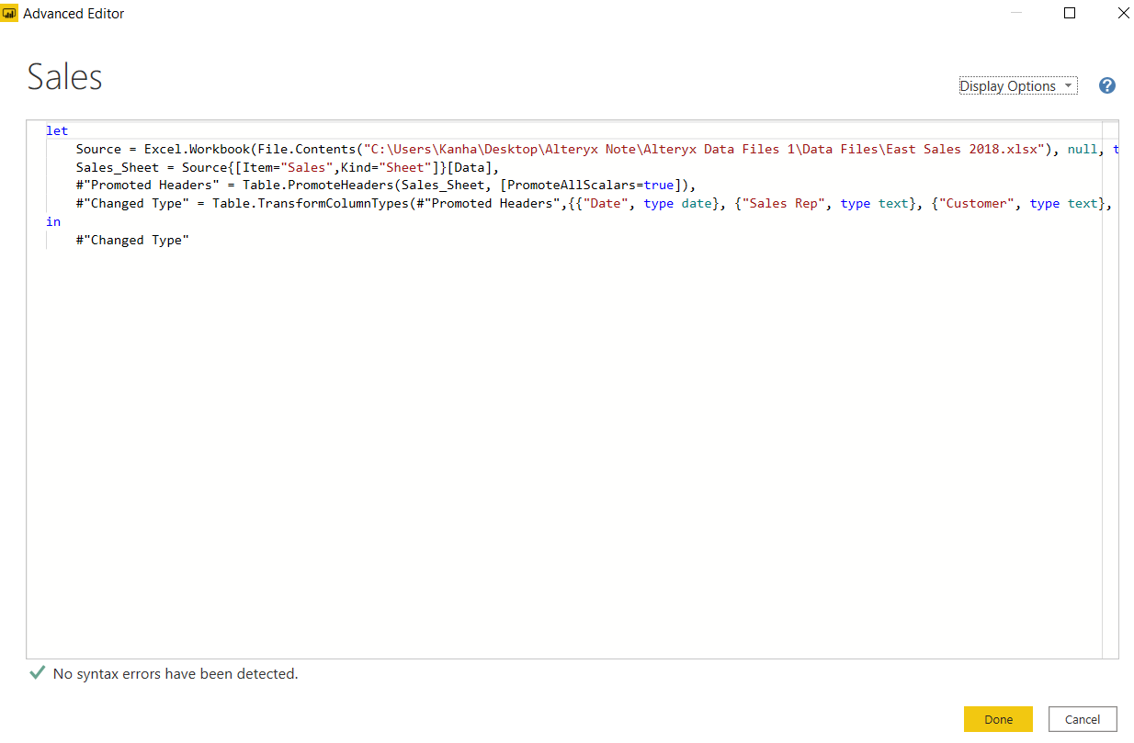

We can directly edit the code in the **Advanced Editor** window. To close the window, we have to select the **Done** or **Cancel** button.

1. **Prepare a document with details of the following along with their price**

* Power BI Free
* Power BI Pro
* Power BI Premium

|  |  |  |  |
| --- | --- | --- | --- |
| COMPARISION | | | |
|  | **Power BI Free** | **Power BI Pro** | **Power BI Premium** |
| Pricing | Free | INR 660 M/User | INR 330190 M/dedicated cloud compute & storage resource with annual subscription |
| Included with Office 365 |  | Yes | It can be added to any Power BI pro deployment |
| Licensed Per | User | User | by dedicated cloud compute & storage resources |
| Data Refresh Rate | 8/day | 8/day | 48/day |
| Unrestricted Report Sharing | Yes | Yes | Yes |
| Export to CSV, XLS, PDF & PPTX |  | Yes | Yes |
| Embed Visuals into Apps(Teams, SharePoint, etc) |  | Yes | Yes |
| Storage Limit | 10GB | 10GB | 100TB |
| Fixed paginated layout for printing |  |  | Yes |
| Incremental data refresh |  |  | Yes |
| Analyze data in Microsoft Excel | Yes | Yes | Yes |
| View and interact with Power BI content | Yes | Yes | Yes |
| View and interact with Power BI content through the Power BI mobile app for iOS, Android, and Windows | Yes | Yes | Yes |